Simple File List DotNetNuke® Module

User Documentation

Document Version: 2.00

Prepared By: Mitchel Sellers

Reviewed By: Mitchel Sellers

Date Created: 7/2/2011

Date Last Modified: 7/2/2011

Table of Contents

Revision History 3

Disclaimer 3

Copyright and Trademark Notices 3

1. Module Overview 4

1.1 Summary 4

1.2 Module Features 4

1.3 Dependencies 4

1.3.1 Minimum DNN Version 4

1.3.2 Other Dependencies 4

2. Module Installation 4

3. Administrator/Edit Permission Usage 4

3.1 Overview 4

4. View Permission Usage 5

5. Support and Requests 5

5.1 Support Forums 5

5.2 Feature Requests 5

5.3 Module Version History 5

6. IowaComputerGurus Inc. Contact Information 6

Revision History

|  |  |  |  |
| --- | --- | --- | --- |
| Name | Date | Change and Reason For Changes | Version |
| Mitchel Sellers | 3/20/2011 | Initial documentation creation | 1.01 |
| Mitchel Sellers | 7/2/2011 | Updated for Version 2.00 of module | 2.00 |
|  |  |  |  |
|  |  |  |  |

Disclaimer

This document is provided as an additional source of information on the usage of this module. Module content, features, and functionality are subject to change at any time and will be distributed to the public with unique version numbers. It is the reader’s responsibility to ensure that this documentation matches the current version of the module in question. Additionally the reader understands that by using this documentation and the module that they agree to the terms of use, posted on the IowaComputerGurus.com website and available from all module download pages.

Copyright and Trademark Notices

The information contained within this document is protected under international copyright laws with a content owner of IowaComputerGurus Inc. This document may be re-distributed to anyone, however, it must remain intact and with this disclaimer visible.

DotNetNuke and DNN are both registered trademarks of DotNetNuke corporation.

# Module Overview

## Summary

The Simple File List module is a simple utility module that allows users to show all files within a specific directory within their DotNetNuke portal. This module does not allow for any additional “metadata” to be associated with individual files and simply works with the filename and a download link.

## Module Features

* Allows administrators to quickly create a dynamic page showing the contents of a directory within their portal.
* Allows for automatic updating based on FTP dropped files.
* Allows for administrator specified filters on files that should be shown

## Dependencies

### Minimum DNN Version

This module requires DotNetNuke version 05.02.00 and later to function properly

### Other Dependencies

At this time the module has no dependencies other than the DotNetNuke requirement.

Security Notice

Given the

# Module Installation

Module is installed the same as any other DotNetNuke module.

# Administrator/Edit Permission Usage

## Overview

From an administration perspective the module usage is quite simple. Once the module has been added to a page, a display similar to the following will direct users to configure the module:

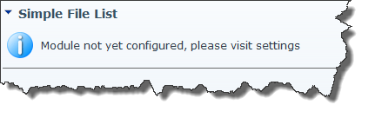

Simply navigate to the “Settings” view for the module and you will see the following screen

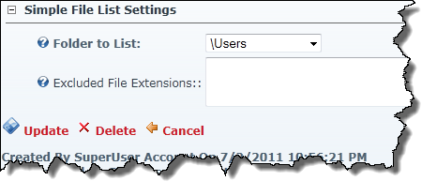

From here a listing of folder within the current “portals” folder will be presented, select the folder you would like to display. Using the “Excluded File Extensions” option you can input a list of file extensions that should be excluded from the display within the module.

# View Permission Usage

When users login they will see a listing of all files in the folder that have not been excluded via the “Excluded File Extensions” process. The display will be similar to the following image.

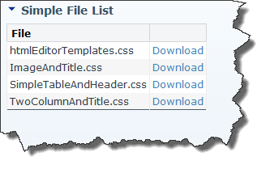

# Support and Requests

## Support Forums

IowaComputerGurus Inc. maintains a [Support Forum](http://www.iowacomputergurus.com/forums.aspx) that allows users to submit support requests for this module. We strive to respond to all customer questions within 24-48 hours or sooner if possible. A link to the support forums can also be found in the “Action Menu” of each module instance.

## Feature Requests

As a free module development of this module is completed on a “as time exists” basis and new features are based greatly on user feedback. If you have a feature that you would like to see in a future version of this module please log it as a request in the support forum, or contact us [webmaster@iowacomputergurus.com](mailto:webmaster@iowacomputergurus.com) and we will gladly see what we can do to get it implemented.

If you would like to sponsor the development of a feature for this module options are available for this as well. If a feature is sponsored the edit log will be updated to reflect the sponsoring individual or organization.

## Module Version History

All free modules provided by IowaComputerGurus Inc. are available with full source code if you have a need to modify the modules outside of the scope of our regular updates. Doing this will take you outside the scope of being able to upgrade in the future, the only requirement for use is that all copyright statements remain intact on all files.

# IowaComputerGurus Inc. Contact Information

IowaComputerGurus Inc. 12508 Horton Avenue, Urbandale, Iowa 50323

**Phone**: (515) 270-7063

**Fax**: (866) 591-3679

**Email**: [webmaster@iowacomputergurus.com](mailto:webmaster@iowacomputergurus.com)

**Website**: <http://www.iowacomputergurus.com>

**Support**: <http://iowacomputergurus.kayako.com>